**Module-3: Docker – I Assignment - 2**

You have been asked to:   
● Save the image created in Assignment 1 as a Docker image   
● Launch container from this new image and map the port to 81   
● Go inside the container and start the apache2 service

● Check if you are able to access it on the browser

Steps done :

Saving the image from already created container with help of docker commit command

And docker run command has been used to create a container out it from the saved image

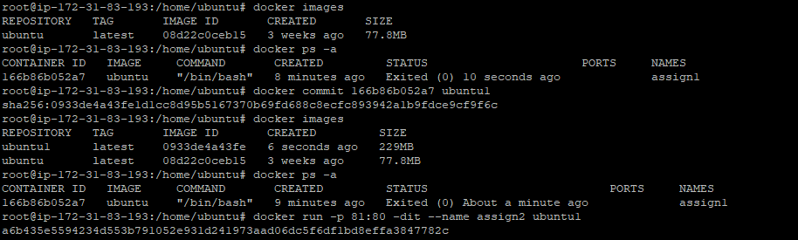

Login to the container and started the service

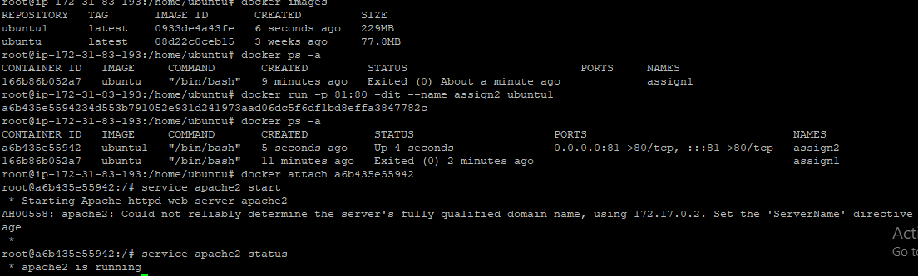

Added the incoming rule for port 81

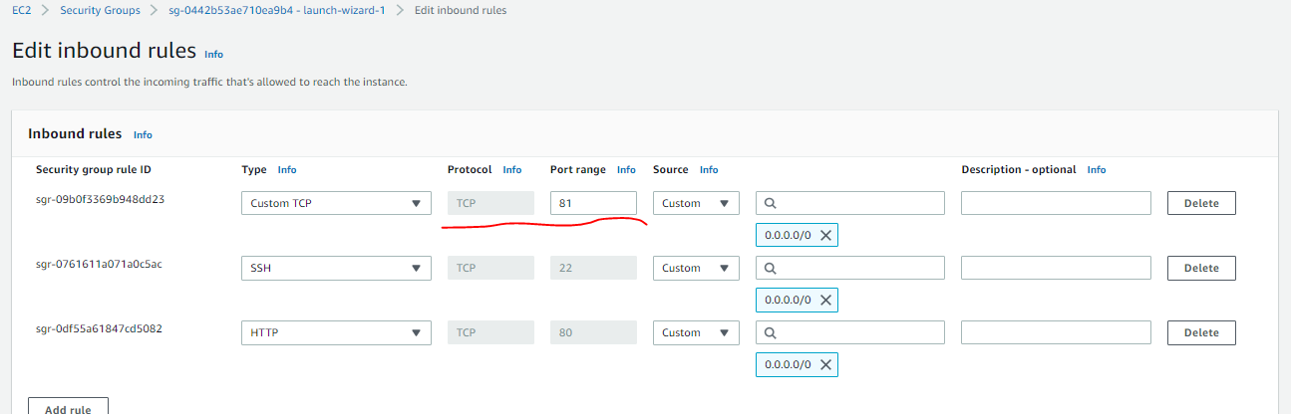

Now webpage is working fine after allowing inbound traffic

